The Kingdom’s Curse
A plot/Concept
After the war with the rebellions, a soldier stranded on the battlefield tries to find its way back home (to his little brother) and his purpose in the world. Resulting in the revelation that his little brother was on the side of the rebellions and that the current king (his best friend) is the real culprit.
Outline (First the script or game design?)
For this user’s case, the story will come first. This means that firstly the script will be written, and a game design will be created around it.
Worldbuilding
The story will be located inside of a vast kingdom. This kingdom is surrounded by a wall, which hasn’t been crossed in over 50 years. The previous king forbad it. It’s said that the wall is meant to keep the monsters out, but any information about these creatures is lost to time. In the center of the kingdom, the castle is located. The castle is big and only the king lives here. On the outskirts of the castle, there are houses where the commoners live. In this kingdom there is no distinct difference between the rich and the poor. The rest of the kingdom consists of small villages and farms.
In the past years the kingdom started to turn grimmer. People started to go missing, food was getting scares, weather going crazy, and chaos is brewing. Because of this a rebellion started to go against the king, who they believed was the source of all the chaos in the kingdom. Most of these villages have been destroyed because of the war against the rebellion.
Characters
The soldier, the player, name: Gerren
Description:
Gerren is 27 years old. He wears worn down armor and carries his sword on his waist. He carries the drawing he got from his little brother so long ago.
Backstory:
Gerren was born in a village on the south-east side of the castle called Hylldune. He lived here with his little brother, working on the farms and doing choirs. The were raised by their village, not knowing anything about their parents. When the rebellion started, Gerren felt obliged to help his king (his friend) in the war and joined the army.
Personality traits:
Positive: Kind, Loyal.
Negative: Naïve, Stubborn.
Bonds:
The only family member he has: his little brother Bryn. Even though he could really be a hand full, he was always there for him.
Gerren’s best friend is the king Langarus, which he tries to visit as much as he can. The became friends long ago, when the king came to fist their village about 13 years ago.
The village, who tried to keep them as much out of trouble as possible.
Ideals:
He always tries to do the right thing.
The little brother, name: Bryn
Description:
Bryn is 22 years old. He is agile and so doesn’t like wearing constraining clothes as they limit his movement. This is why is mostly seen with rolled up trouser legs and shirt sleeves.
Backstory:.
Just like his brother, Bryn grew up in Hylldune. Unlike his brother, he liked to adventure around their village, always dreaming for more. When the rebellion started, and his brother left, Bryn started to wonder what’s right and what’s wrong. He concluded that he was on board with the rebellion when soldiers attacked the village.
Personality traits:
Positive: Jokester, Adventures, Moral Sense.
Negative: Impulsive
Bonds:
His brother. He loves him, even though it’s sometimes hard for him to show it. Its broke Bryn’s heart when he went to the war. Afraid he would never see him again.
His village. Everyone he knows lives there.
Ideals:
He would love to see what is on the other side of the wall.
Likes to try new things.

The king, name: Langarus the Great
Description:
Langarus is 35 years old. He never cared for wealth or anything fancy, so he tries to wear common clothing whenever he can. Whenever he must, he wears the classic king clothing.
Backstory:
King Langarus the Great has been a king for more than 10 years now. He is beloved by everyone and takes care of his people. This was until the rebellion started.
His family has a secret, a secret no one is ever allowed to find out. He went behind the wall and is cursed by one of these “monsters”. No matter how hard he would try, what he would do, his influence will cause chaos in the realm. This is all the fault of his father, which was the cause of the “monster” to cast the curse.
Personality traits:
Positive: Resilient, Kind.
Negative: Secretive, Disoriented.
Bonds:
Gerren is his best friend and the only one he thinks likes him as he is. He was the only one he almost talked to about the curse. He hated it that Gerren decided to fight in the war.
His kingdom.
Ideals:
He would do anything to prevent anybody to cross the wall. If this meant war, this meant war. He believes that if his family line doesn’t stay on the throne, people would think about going over the wall again.
Story flowchart
The following flowchart is of the first level only. This will be the level used for the rest of the R&D.
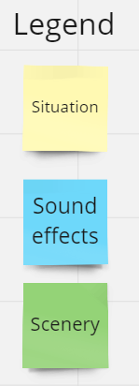
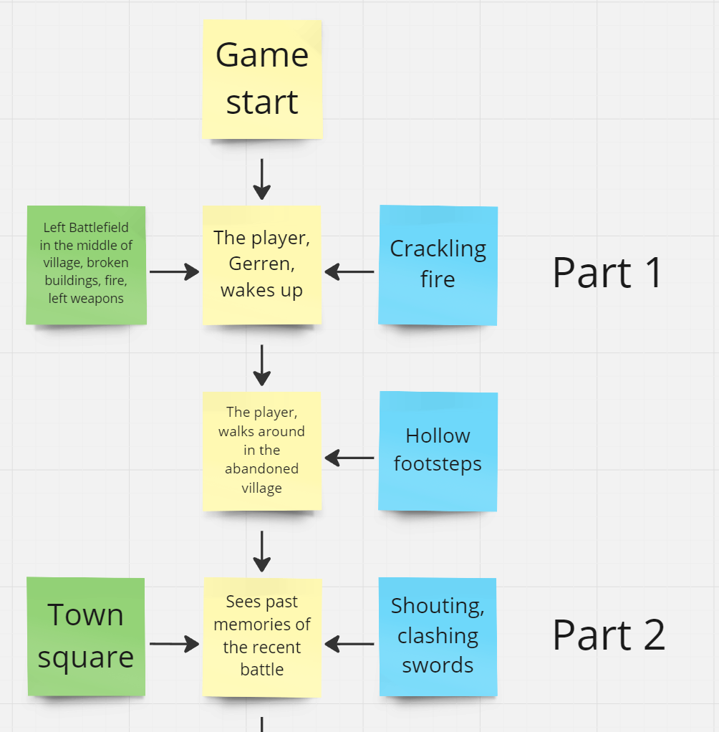
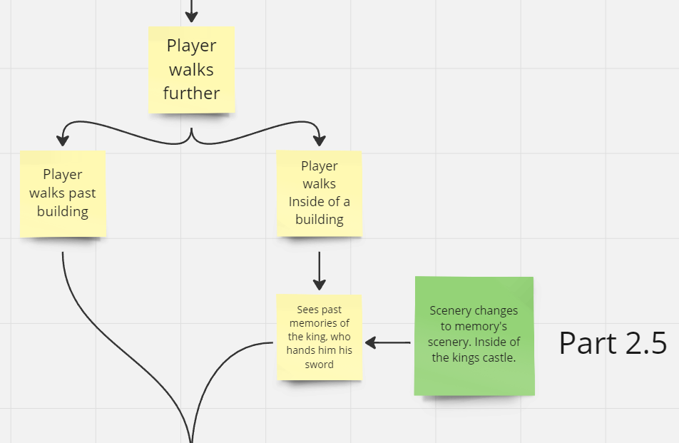
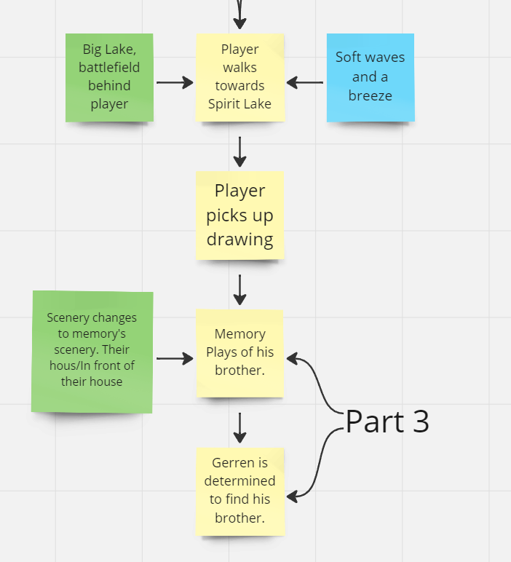
Link to the full board:
https://miro.com/app/board/uXjVMgotfwU=/?share_link_id=117237231089
Side stories/side quests
This research will only contain one level of the story (shown in the story flowchart). This level does not have any side quests or stories, so non are needed.
Reviewing
When checking the progress with a peer, they said that they were invested in the story. The only thing that I had to keep in mind was that I will have to translate all of this to a game without dialogue.

